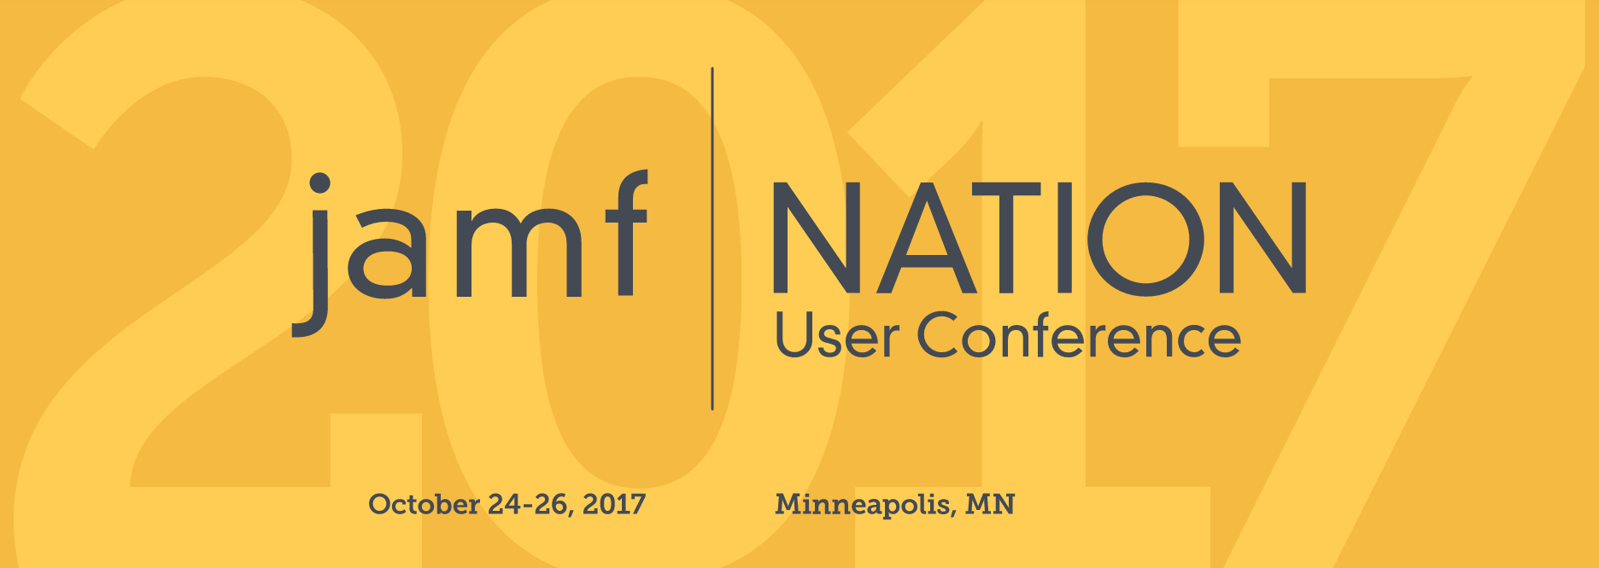

Hello [manager],

I’m writing to request approval to attend the 2017 Jamf Nation User Conference (JNUC) in Minneapolis, Minnesota. Running October 24-26, JNUC is a three-day rally that brings together the best and brightest minds in Apple IT.

Last year, over 1,200 people attended JNUC 2016. I would like to attend JNUC 2017 for two reasons: (1) I believe it will help me become more efficient in doing my job; and (2) I can help create greater value for our organization. As you consider this request, I’d like to make three points about the conference:

1. JNUC is one of the most affordable conferences in the industry.

Here are a few other large, Apple-focused conferences:
- WWDC in San Jose, CA for $1,599;
- MacSysAdmin in Gothenburg, Sweden for $1,300;
- 360iDev in Denver, CO for $1,049; and
- MacTech in Los Angeles, CA with a super early bird special of $899.

The JNUC is the lowest we’ll find for any conference of this size, scope and access to Apple expertise. Since it is hosted in Minneapolis, MN, with pre-negotiated hotel rates, lodging is also very low compared to other conferences.

2. JNUC provides unparalleled access to training and expertise.

Most conferences of this size are found in California, Las Vegas or Florida. JNUC is hosted in Minneapolis in late October. The location isn’t chosen as a ‘getaway’ for attendees. Minneapolis is the host city because that’s where Jamf is headquartered. As a result, Jamf is able to staff the event with their best engineers, support specialists and consultants. This kind of access only occurs at JNUC, and will provide me with the opportunity to speak face-to-face with the people we depend on for the rest of the year. My job, while at JNUC, will be to make sure we have the contacts to ensure I always find the person who can most help our organization.

In addition, JNUC draws hundreds of Jamf customers, partners and Apple industry experts. It creates an environment where I can find the right people to learn best practices, address challenges and set us up for future success. If allowed to go, I will hear from the architects of the largest Apple deployments on earth and the most innovative use of technology for the purpose of learning and working. Last year, IBM presented their Apple implementation and explained how they did it while making and saving money with every Mac purchase. And, that was only one of several dozen presentations where organizations not only present what they do, but how they do it.

3. JNUC 2017 gives me early access to technology we must learn.

Recently, Jamf doubled the size of its engineering team. This means there will likely be functionality introduced at JNUC 2017 that I’ve never seen before. Having the opportunity to touch it for the first time while surrounded by consultants and the very developers who built it means that I will be able to implement that technology faster and with more confidence. Plus, Jamf promised attendees that we will also see the technology they are working on for 2018. This year’s JNUC is my opportunity to see what is coming in the future, and provide feedback that can direct Jamf’s work going forward.

Between the Jamf-led and customer-led sessions, countless product demos and education courses, this is our best opportunity to turn all of the IT aspirations we’ve discussed into realities. For all of the times we’ve said, “I wish we could just…” we can now say, “I am so happy we can…”

In this industry, a good consultant can cost thousands of dollars per day. Attending JNUC provides the opportunity to be surrounded by the industry’s best Apple consultants, support specialists and engineers for three full days! It is perhaps the best value-for-dollar investment we can make.

Thank you for considering this tremendous opportunity. Feel free to check it out for yourself at: https://www.jamf.com/events/jamf-nation-user-conference/2017/

Sincerely,

[name]

